**Aim:** Analysis of Superstore Dataset

**IDE:** Microsoft Excel, Tableau , Spyder

**Pre-Requisites:-**  Insert the Customer’s Full Name, Gender, City, and Country From the Customer Sheet Using VLOOKUP

Function In Order Dataset In Excel Itself on the Basis of Customer ID.

**Now Import Necessary Libraries for Analysis:-**

import pandas as pd

import numpy as np

import seaborn as sns

import matplotlib.pyplot as plt

Dataset = pd.read_excel("./Superstore.xlsx",'Orders')

Dataset['Order_Date'] = pd.to_datetime(Dataset['Order_Date'])

Dataset["Year"] = Dataset["Order_Date"].dt.year

Dataset["Quater"] = Dataset["Order_Date"].dt.quarter

Dataset["Month"] = Dataset["Order_Date"].dt.month

**Questions:**

1. **What are the product categories available for customers to shop?**

**Code:-**

Unique_Categories = list(set(Dataset["Category"]))

plt.figure(figsize=(16, 8))

plt.bar(x=["No Of Unique Categories"], height=[len(Unique_Categories)], width=0.5)

for i, v in enumerate([len(Unique_Categories)]):

plt.text(i, v + 0.1, str(v), ha="center")

plt.show()

**Output :-**

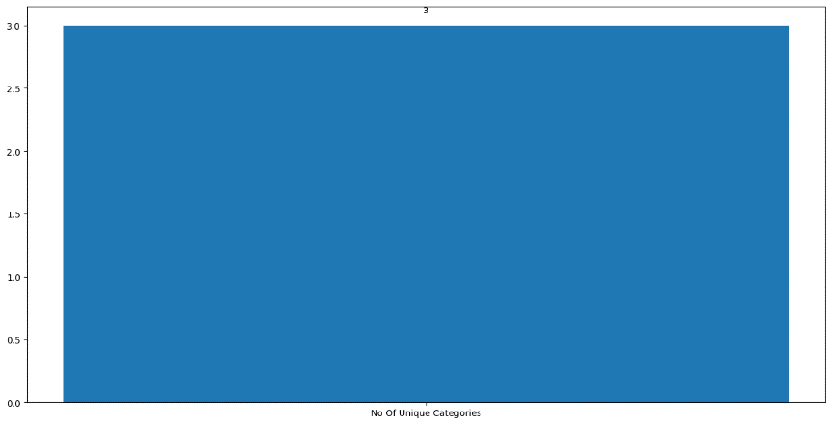

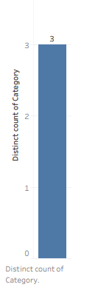**Tableau Workbook :-**

1. **How many products are there in each category?**

**Code:-**

plt.figure(figsize=(20, 10))

ax = sns.countplot(x=Dataset["Category"], hue=Dataset["Category"])

for p in ax.patches:

ax.annotate(

f"{p.get_height()}",

(p.get_x() + p.get_width() / 2.0, p.get_height()),

ha="center",

va="center",

fontsize=12,

color="black",

xytext=(0, 5),

textcoords="offset points",

)

plt.show()

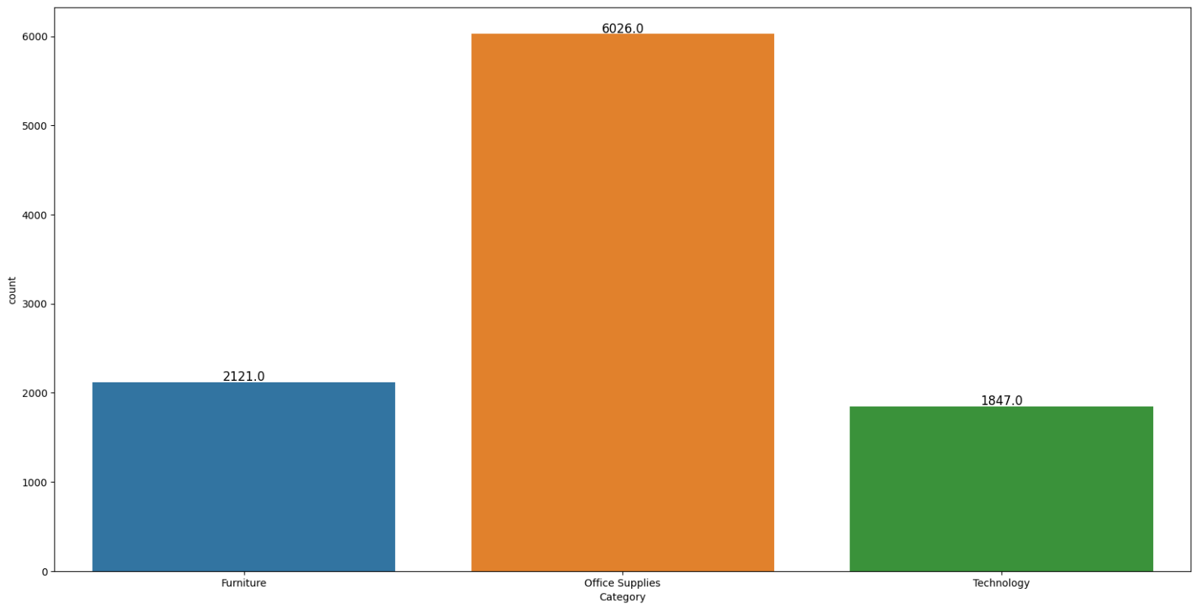**Output :-**

**Tableau Workbook :-**

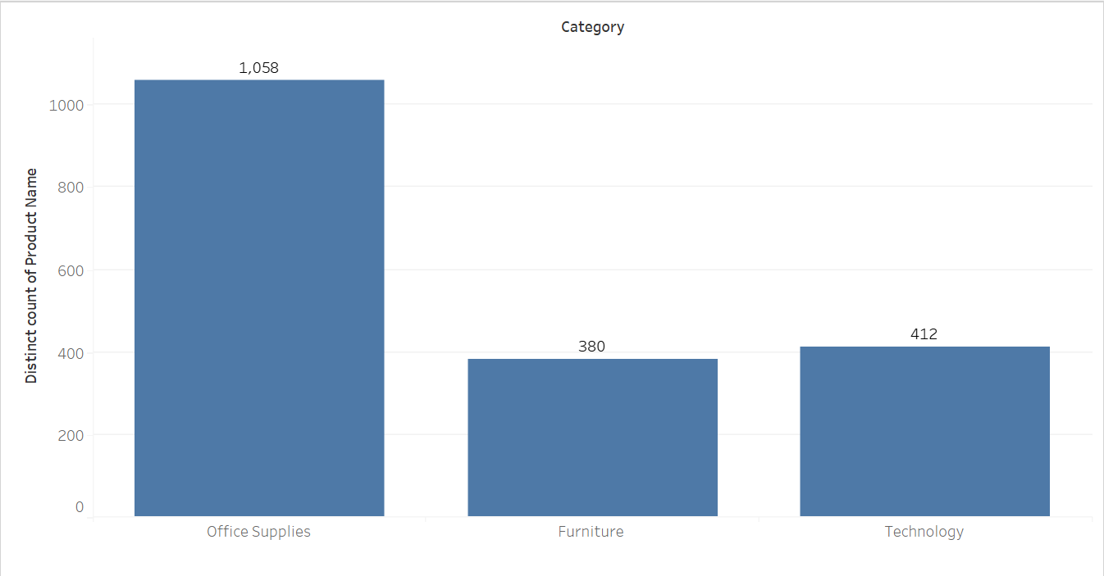

1. **What is the count of products in each sub-category?**

**Code:-**

Sub_categgory_wise_product_distribuition = Dataset["Sub-Category"].value_counts()

print(Sub_categgory_wise_product_distribuition)

plt.figure(figsize=(20, 10))

ax = sns.countplot(x=Dataset["Sub-Category"], hue=Dataset["Sub-Category"])

for p in ax.patches:

ax.annotate(

f"{p.get_height()}",

(p.get_x() + p.get_width() / 2.0, p.get_height()),

ha="center",

va="center",

fontsize=12,

color="black",

xytext=(0, 5),

textcoords="offset points",)

plt.show()

**Output :-**

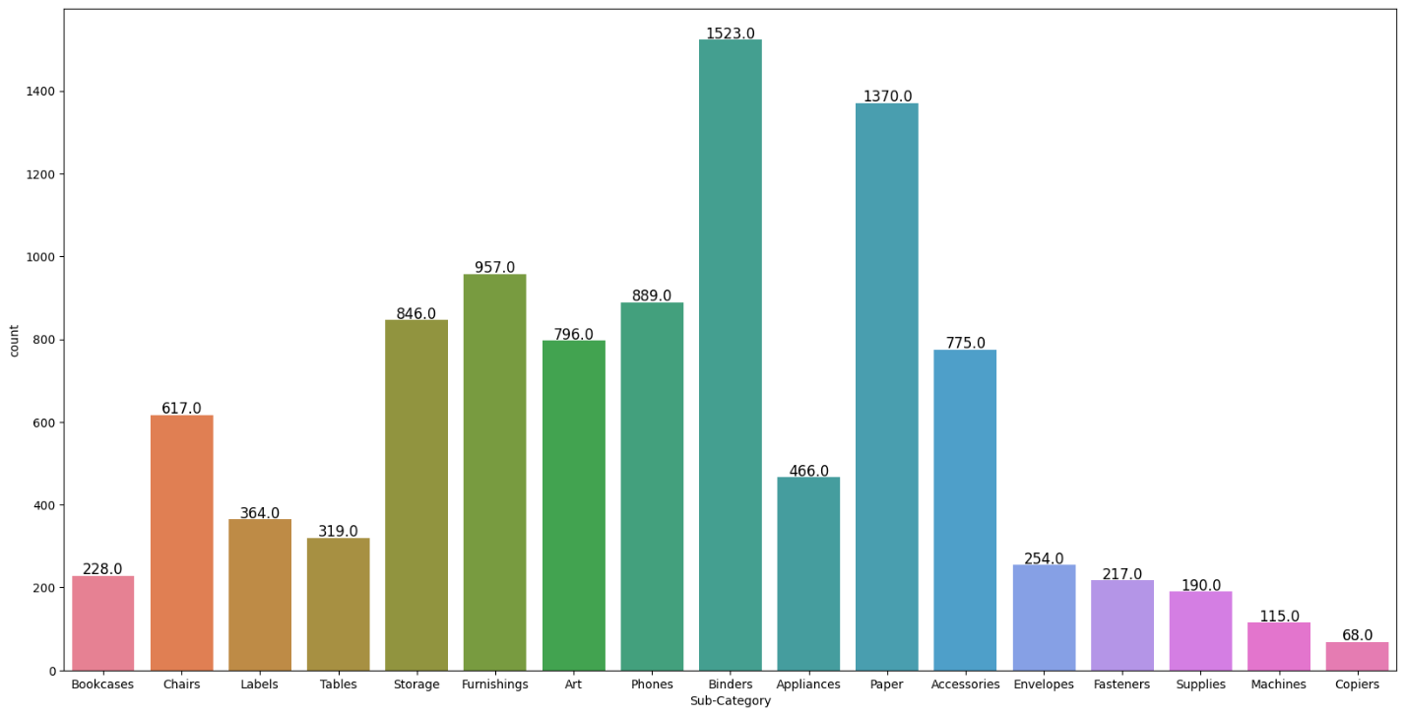

**Tableau Workbook :-**

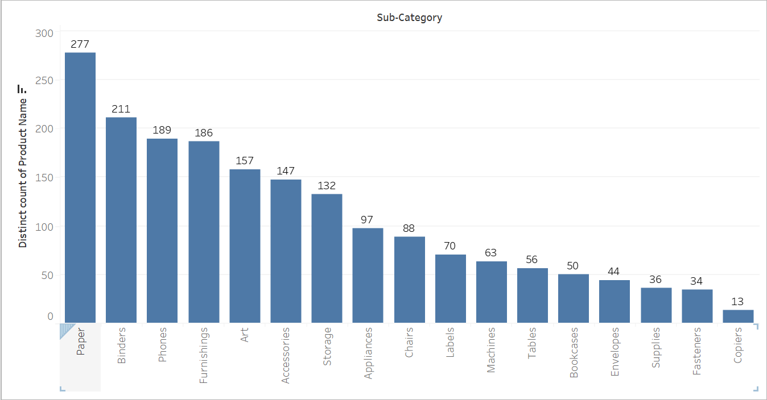

1. **How are sub-categories distributed in relation to their respective categories?**

**Code:-**

Distribution_of_sub_categgory_wrt_Category = Dataset.groupby('Category')['Sub-Category'].unique()

print(Distribution_of_sub_categgory_wrt_Category)

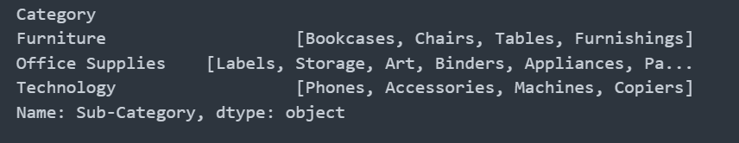**Output :-**

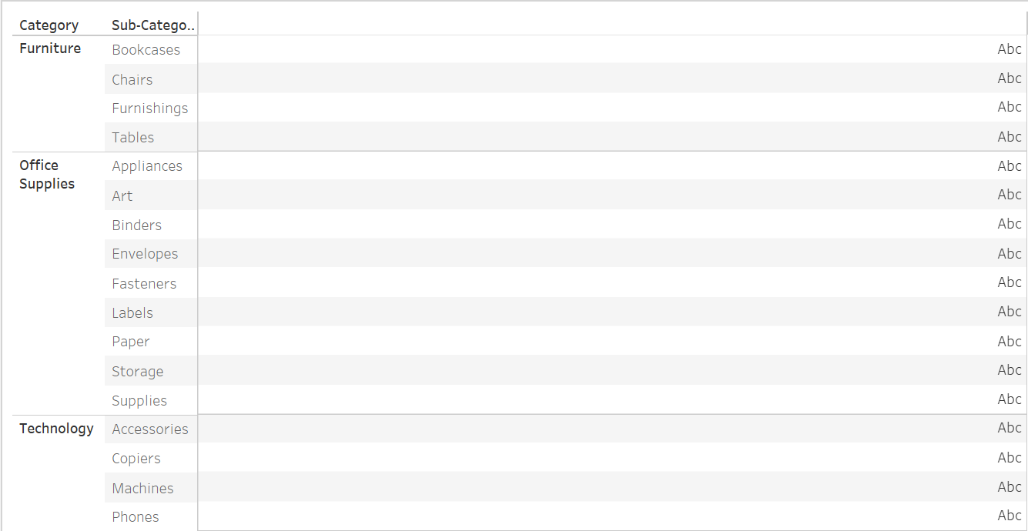**Tableau Workbook :-**

1. **What is the percentage distribution of varieties of Office Supplies?**

**Code:-**

Office_Supplies_Distribution = (

Dataset[Dataset["Category"] == "Office Supplies"]["Sub-Category"]

.value_counts()

.rename("Counts")

)

total_office_supplies = Office_Supplies_Distribution.sum()

Office_Supplies_Distribution_with_percentage = (

Office_Supplies_Distribution / total_office_supplies

) * 100

Office_Supplies_Distribution_with_percentage = (

Office_Supplies_Distribution_with_percentage.rename("Percentage")

)

Distribution_of_office_Supplies = pd.concat(

[Office_Supplies_Distribution, Office_Supplies_Distribution_with_percentage], axis=1

)

plt.figure(figsize=(10, 6))

plt.pie(

Distribution_of_office_Supplies["Counts"],

labels=Distribution_of_office_Supplies.index,

autopct="%1.1f%%",

startangle=140,

)

plt.title("Distribution of Office Supplies by Sub-Category")

plt.axis("equal")

plt.show()

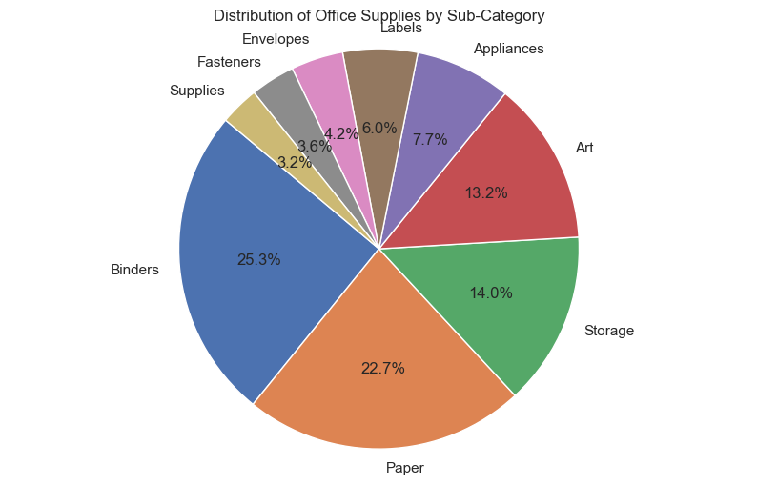**Output :-**

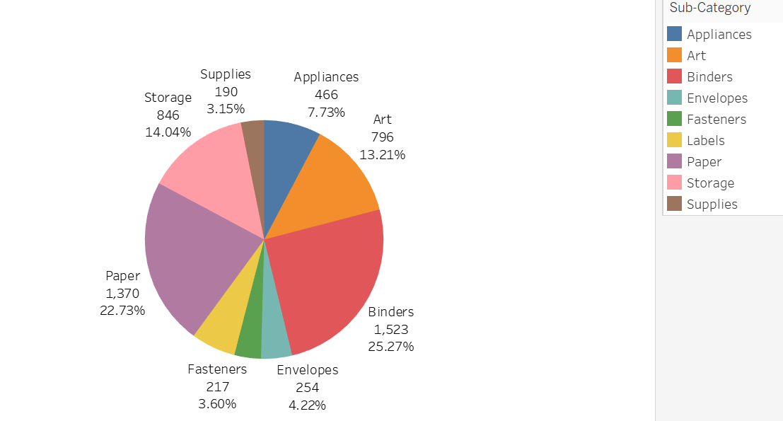**Tableau Workbook:-**

1. **What is the percentage distribution of varieties of Technology?**

**Code:-**

Technology_Distribution = (

Dataset[Dataset["Category"] == "Technology"]["Sub-Category"]

.value_counts()

.rename("Counts")

)

total_technology = Technology_Distribution.sum()

Technology_Distribution_with_percentage = (

Technology_Distribution / total_technology

) * 100

Technology_Distribution_with_percentage = (

Technology_Distribution_with_percentage.rename("Percentage")

)

Distribution_of_Technology = pd.concat(

[Technology_Distribution, Technology_Distribution_with_percentage], axis=1

)

print(Distribution_of_Technology)

plt.figure(figsize=(10, 6))

plt.pie(

Distribution_of_Technology["Counts"],

labels=Distribution_of_Technology.index,

autopct="%1.1f%%",

startangle=140,

)

plt.title("Distribution of Technology by Sub-Category")

plt.axis("equal")

plt.show()

**Output:-**

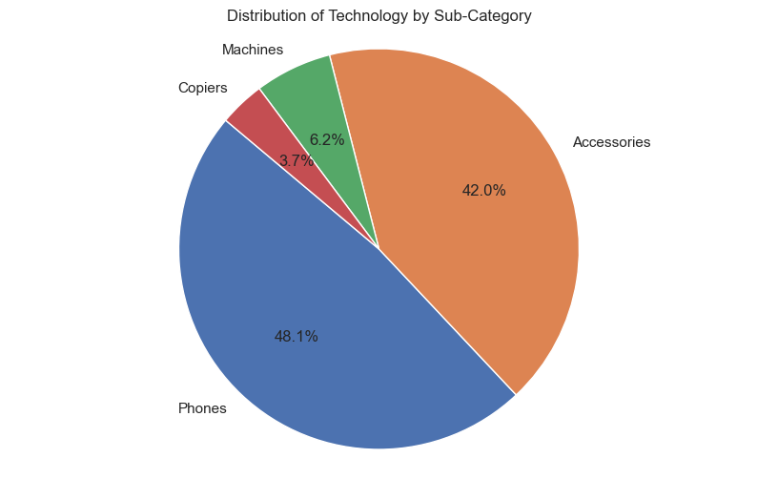

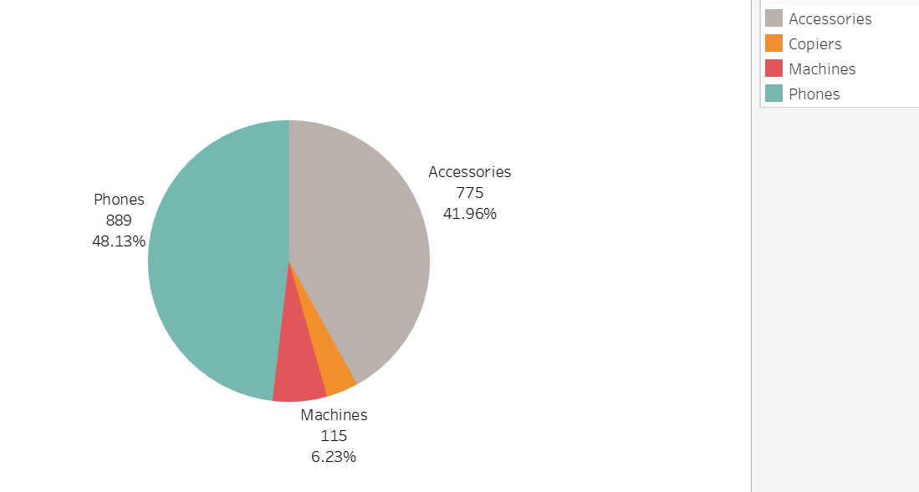**Tableau Workbook :-**

1. **What is the percentage distribution of varieties of Furniture?**

**Code:-**

Furniture_Distribuition = (Dataset[Dataset["Category"] == "Furniture"]["Sub-Category"].value_counts().rename("Counts"))

total_furniture = Furniture_Distribuition.sum()

Furniture_Distribution_with_percentage = (Furniture_Distribuition / total_furniture) * 100

Furniture_Distribution_with_percentage = Furniture_Distribution_with_percentage.rename("Percentage")

Distribution_of_Furniture = pd.concat([Furniture_Distribuition, Furniture_Distribution_with_percentage], axis=1)

print(Distribution_of_Furniture)

plt.figure(figsize=(10, 8))

plt.pie(

Distribution_of_Furniture["Counts"],

labels=Distribution_of_Furniture.index,

autopct="%1.1f%%",

startangle=140,

)

plt.title("Distribution of Furniture Sub-Categories")

plt.axis("equal")

plt.show()

**Output :-**

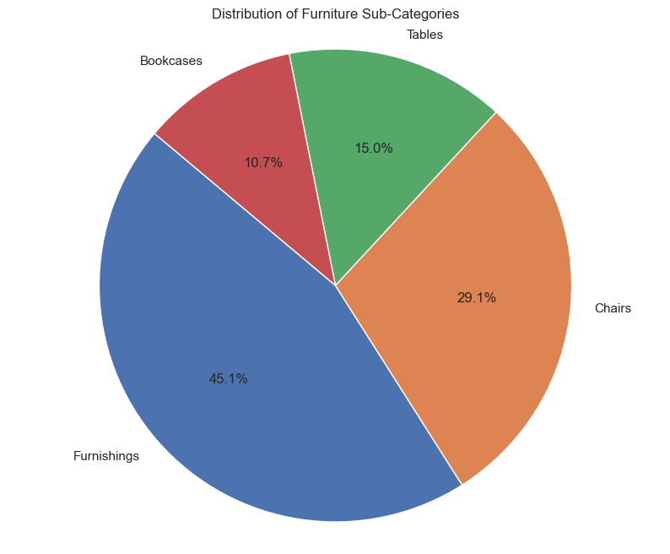

**Tableau Workbook :-**

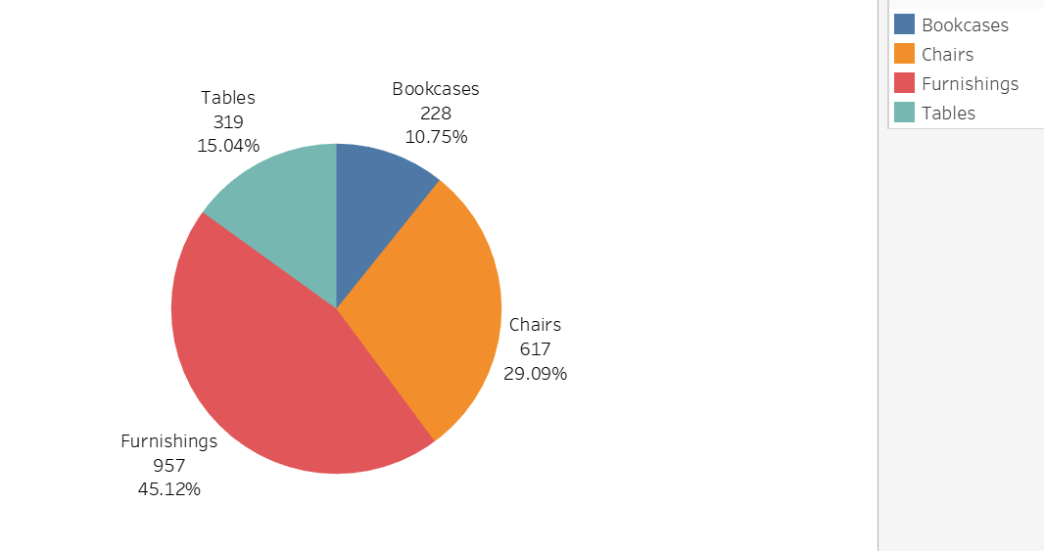

1. **What is the profit and sales data for each sub-category?**

**Code:-**

Category_wise_Sales_and_profit = Dataset.groupby("Sub-Category")[["Profit", "Sales"]].sum()

print(Category_wise_Sales_and_profit)

ax = Category_wise_Sales_and_profit.plot(kind="line", figsize=(12, 6))

plt.title("Category-wise Sales and Profit")

plt.xlabel("Sub-Category")

plt.ylabel("Amount")

plt.grid(True)

plt.legend(loc="upper right")

for column in Category_wise_Sales_and_profit.columns:

for index, value in enumerate(Category_wise_Sales_and_profit[column]):

ax.text(index, value, str(round(value, 2)), ha="center", va="bottom")

plt.tight_layout()

plt.show()

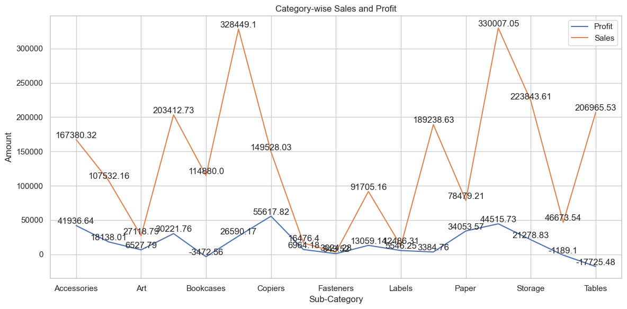**Output :-**

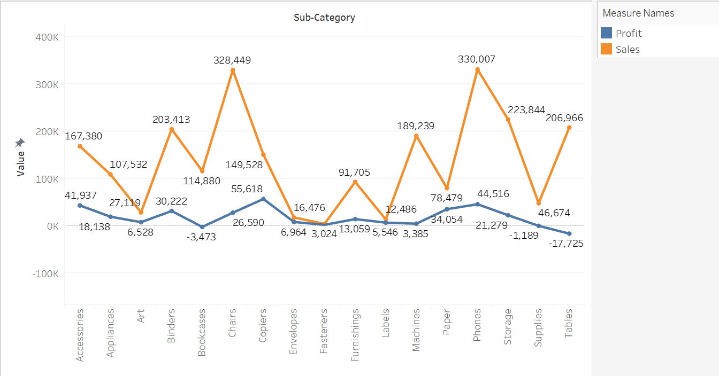**Tableau Workbook :-**

1. **How many unique products have been ordered in the store?**

**Code:-**

Unique_Products = Dataset['Product Name'].unique()

No_of_Unique_Products = Dataset['Product Name'].nunique()

print(f"There are {No_of_Unique_Products} Unique Products :-\n{Unique_Products}")

plt.bar(

x=["No Of Unique Products"], height=[len(Unique_Products)], width=0.5

)

for i, v in enumerate([len(Unique_Products)]):

plt.text(i, v + 0.5, str(v), ha="center")

plt.show()

**Output :-**

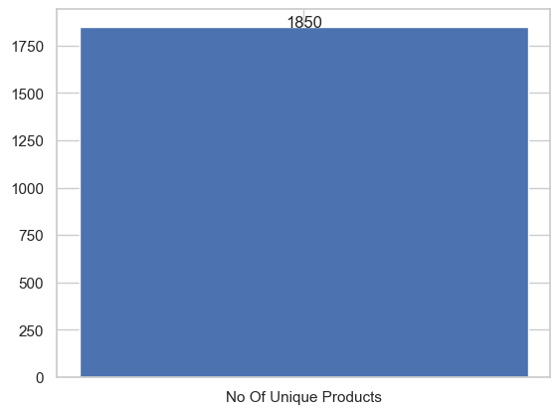

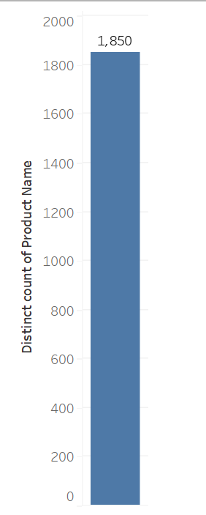**Tableau Workbook :-**

1. **What is the total count of each product ordered in the store?**

**Code:-**

Count_of_Each_Product = Dataset['Product Name'].value_counts()

Data = Count_of_Each_Product[:10]

Data_df = pd.DataFrame({"Product Name": Data.index, "Count": Data.values})

plt.figure(figsize=(20, 10))

ax = sns.barplot(data=Data_df, x="Product Name", y="Count", hue="Product Name")

for p in ax.patches:

ax.annotate(

format(p.get_height(), ".0f"),

(p.get_x() + p.get_width() / 2.0, p.get_height()),

ha="center",

va="center",

xytext=(0, 10),

textcoords="offset points",

fontsize=12,

color="black",

)

plt.xticks(rotation=45)

plt.xlabel("Product Name")

plt.ylabel("Count")

plt.title("Total Count of Each Product Ordered")

plt.show()

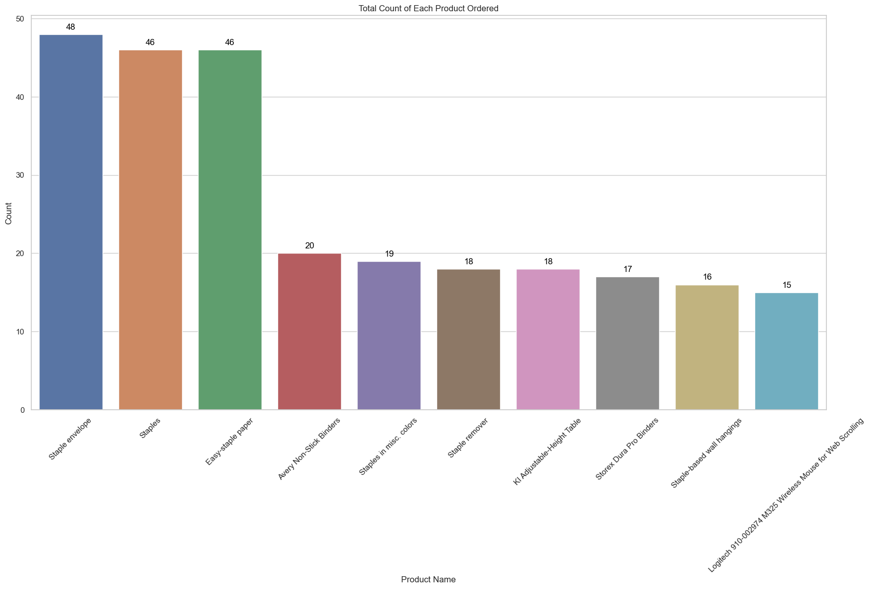**Output :-**

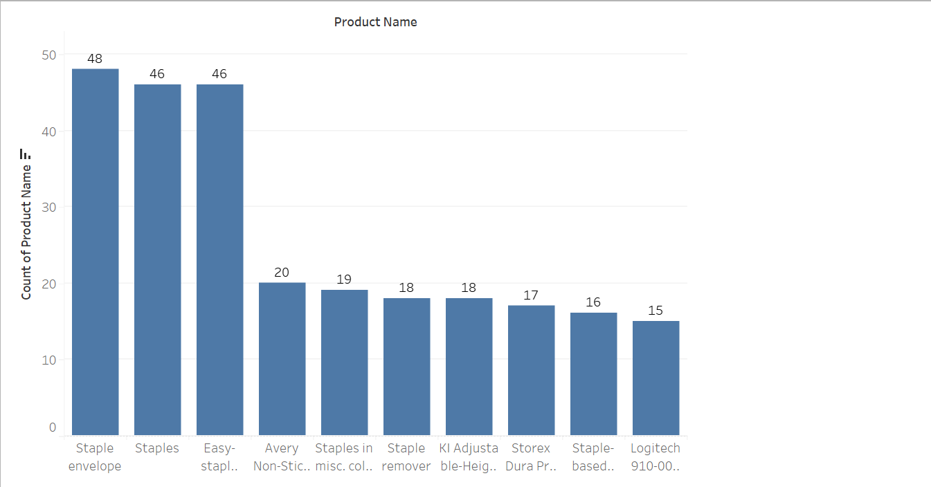**Tableau Workbook :-**

1. **What is the total count of each sub-category region-wise?**

**Code:-**

Region_wise_sub_category_count = Dataset.groupby(["Region", "Sub-Category"]).size().reset_index(name="Count")

plt.figure(figsize=(20, 10))

ax = sns.barplot(

data=Region_wise_sub_category_count, x="Sub-Category", y="Count", hue="Region"

)

for p in ax.patches:

ax.annotate(

format(p.get_height(), ".0f"),

(p.get_x() + p.get_width() / 2.0, p.get_height()),

ha="center",

va="center",

xytext=(0, 10),

textcoords="offset points",

fontsize=10,

color="black",)

plt.xticks(rotation=45, ha="right")

plt.xlabel("Sub-Category")

plt.ylabel("Count")

plt.title("Region-wise Sub-Category Count")

plt.legend(title="Region", loc="upper right")

plt.tight_layout()

plt.show()

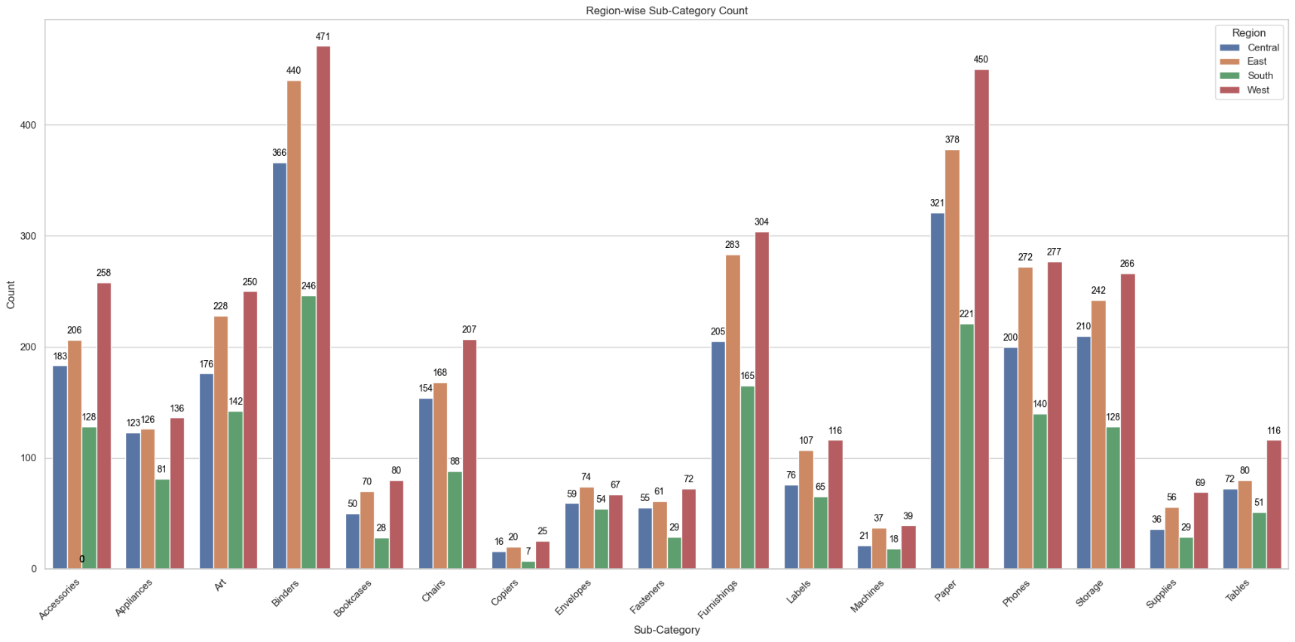**Output :-**

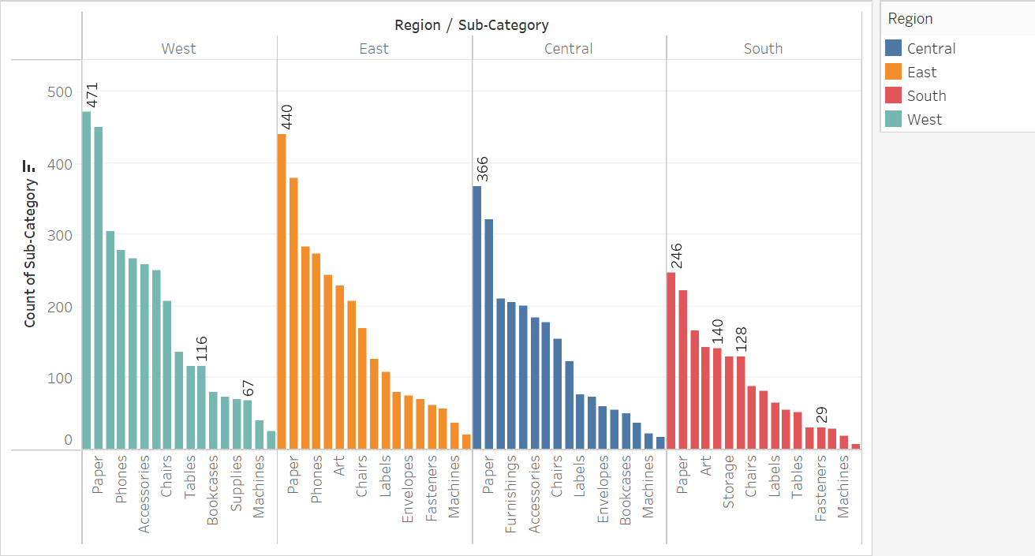**Tableau Workbook :-**

1. **Which product has the highest profit?**

**Code:-**

Max_Profitable_Product = (

Dataset.groupby("Product Name")["Profit"].sum().sort_values(ascending=False)

)[:10]

Max_Profitable_Product_df = pd.DataFrame(

{"Product Name": Max_Profitable_Product.index, "Profit": Max_Profitable_Product.values}

)

plt.figure(figsize=(15, 8))

ax = sns.barplot(

data=Max_Profitable_Product_df, x="Product Name", y="Profit", hue="Product Name"

)

for p in ax.patches:

ax.annotate(

format(p.get_height(), ".2f"),

(p.get_x() + p.get_width() / 2.0, p.get_height()),

ha="center",

va="center",

xytext=(0, 10),

textcoords="offset points",

fontsize=10,

color="black",

)

plt.xticks(rotation=45, ha="right")

plt.xlabel("Product Name")

plt.ylabel("Profit")

plt.title("Top 10 Most Profitable Products")

plt.legend(title="Product Name", loc="upper right")

plt.tight_layout()

plt.show()

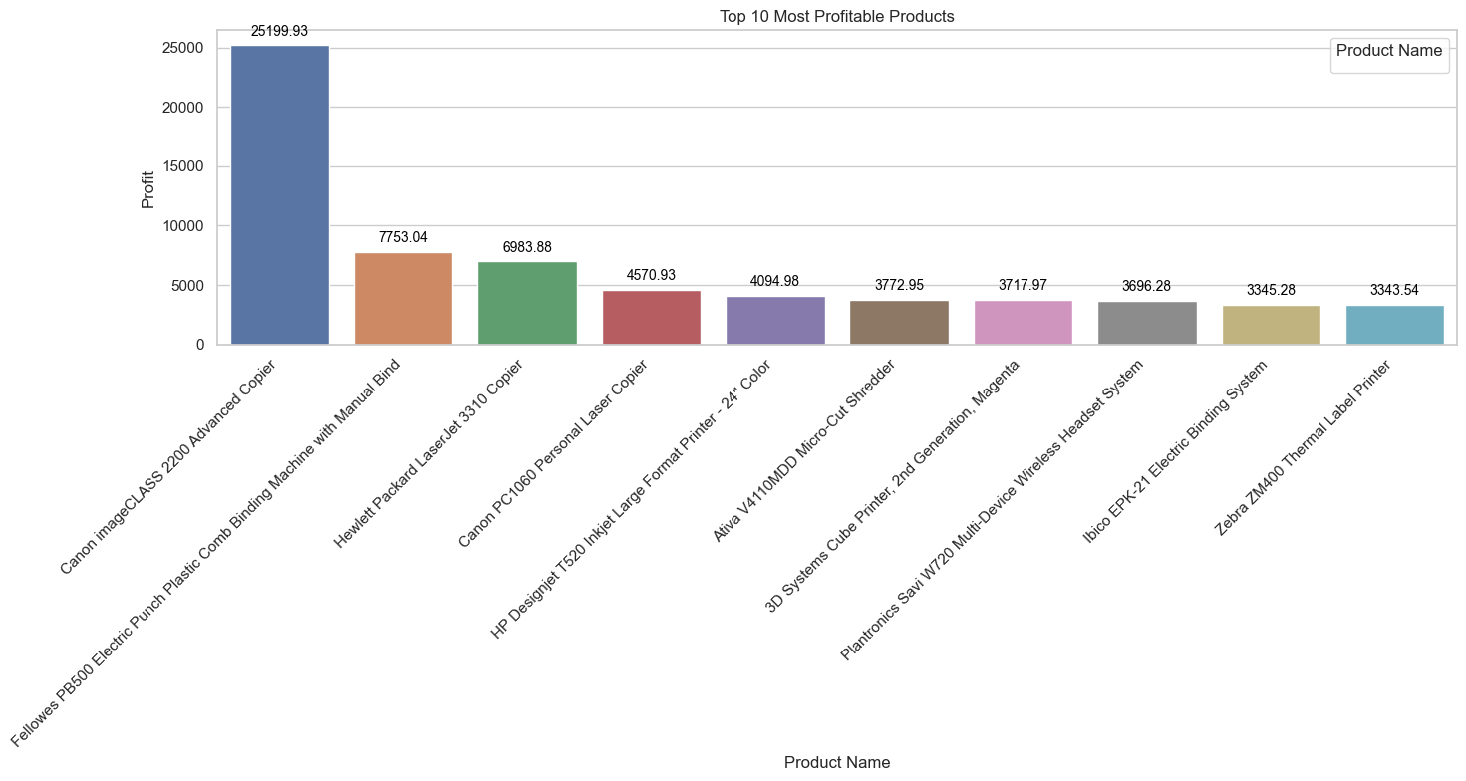**Output :-**

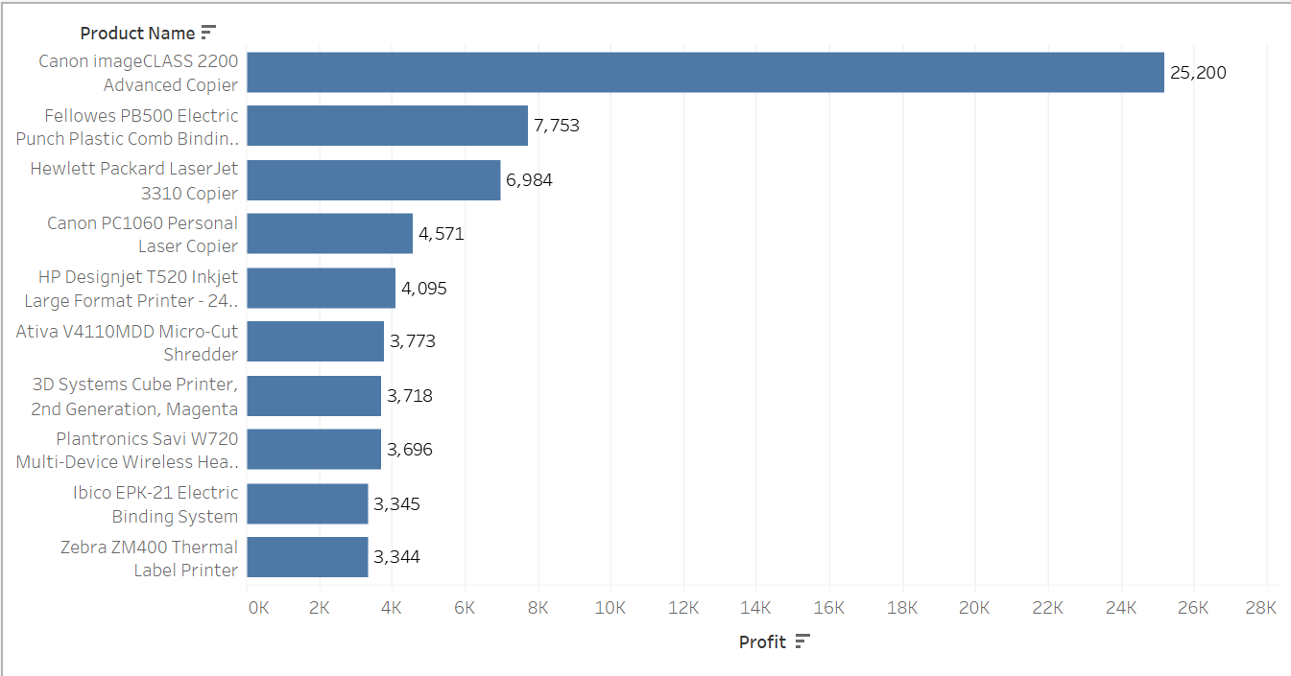**Tableau Workbook :-**

1. **Which sub-category has the highest profit?**

**Code:-**

Max_Profitable_Sub_Category = Dataset.groupby('Sub-Category')['Profit'].sum().sort_values(ascending=False)

Max_Profitable_Sub_Category_df = pd.DataFrame(

{

"Sub-Category": Max_Profitable_Sub_Category.index,

"Profit": Max_Profitable_Sub_Category.values,

}

)

plt.figure(figsize=(15, 8))

ax = sns.barplot(

data=Max_Profitable_Sub_Category_df,

x="Sub-Category",

y="Profit",

hue="Sub-Category",

)

for p in ax.patches:

ax.annotate(

format(p.get_height(), ".2f"),

(p.get_x() + p.get_width() / 2.0, p.get_height()),

ha="center",

va="center",

xytext=(0, 10),

textcoords="offset points",

fontsize=10,

color="black",

)

plt.xticks(rotation=45, ha="right")

plt.xlabel("Sub-Category")

plt.ylabel("Profit")

plt.title("Max Profitable Sub-Category")

plt.legend(title="Sub-Category", loc="upper right")

plt.tight_layout()

plt.show()

**Output :-**

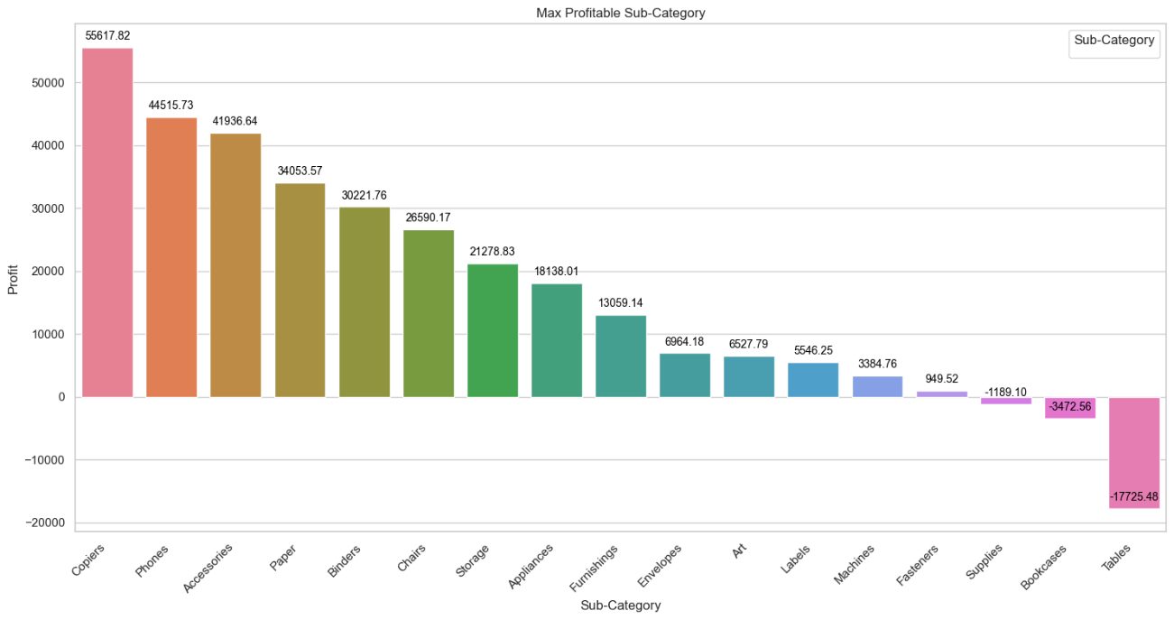

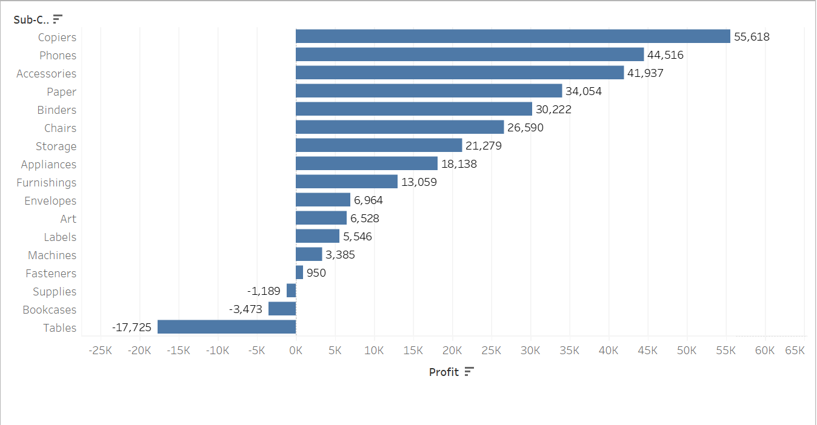**Tableau Workbook :-**

1. **Which product has the highest loss?**

**Code:-**

Max_Loss_Product = Dataset.groupby("Product Name")["Profit"].sum().sort_values(ascending=True)[:10]

Max_Loss_Product_df = pd.DataFrame(

{

"Product Name": Max_Loss_Product.index,

"Profit": Max_Loss_Product.values,

}

)

plt.figure(figsize=(15, 8))

ax = sns.barplot(

data=Max_Loss_Product_df, x="Product Name", y="Profit", hue="Product Name"

)

for p in ax.patches:

ax.annotate(

format(p.get_height(), ".2f"),

(p.get_x() + p.get_width() / 2.0, p.get_height()),

ha="center",

va="center",

xytext=(0, 10),

textcoords="offset points",

fontsize=10,

color="black",

)

plt.xticks(rotation=45, ha="right")

plt.xlabel("Product Name")

plt.ylabel("Profit")

plt.title("Top 10 Most Loss Making Products")

plt.legend(title="Product Name", loc="upper right")

plt.tight_layout()

plt.show()

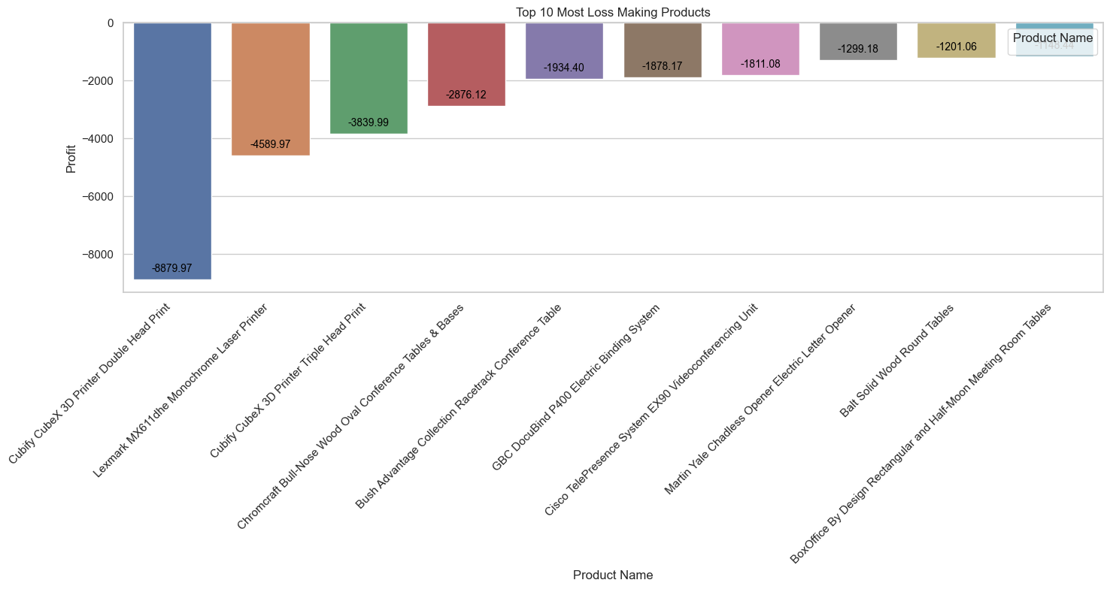**Output :-**

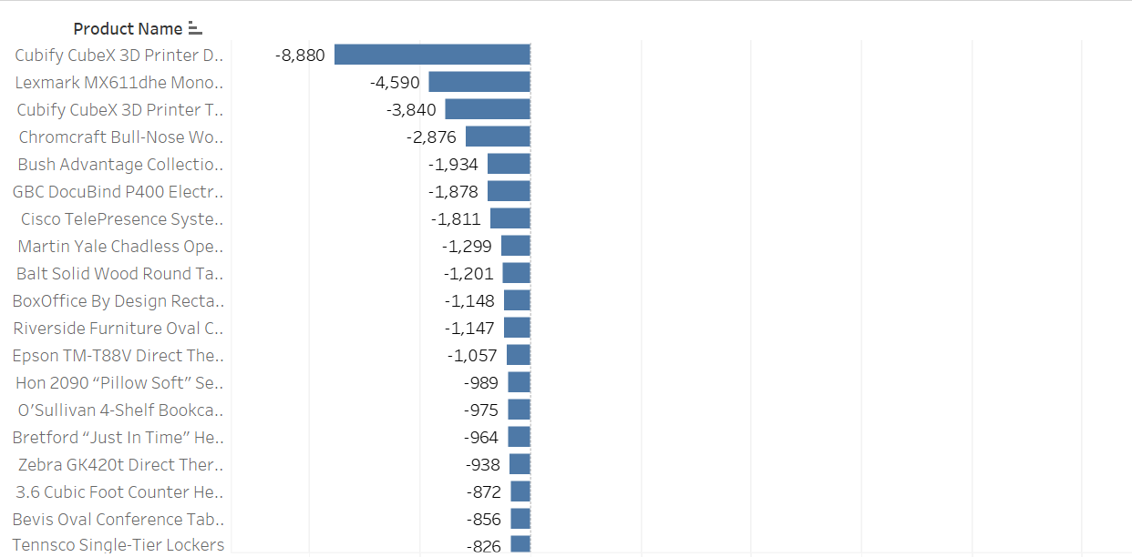**Tableau Workbook :-**

1. **Which sub-category has the highest loss?**

**Code:-**

Max_Loss_Sub_Category = Dataset.groupby("Sub-Category")["Profit"].sum().sort_values(ascending=True)

Max_Loss_Sub_Category_df = pd.DataFrame(

{

"Sub-Category": Max_Loss_Sub_Category.index,

"Profit": Max_Loss_Sub_Category.values,

}

)

plt.figure(figsize=(15, 8))

ax = sns.barplot(

data=Max_Loss_Sub_Category_df,

x="Sub-Category",

y="Profit",

hue="Sub-Category",

)

for p in ax.patches:

ax.annotate(

format(p.get_height(), ".2f"),

(p.get_x() + p.get_width() / 2.0, p.get_height()),

ha="center",

va="center",

xytext=(0, 10),

textcoords="offset points",

fontsize=10,

color="black",

)

plt.xticks(rotation=45, ha="right")

plt.xlabel("Sub-Category")

plt.ylabel("Profit")

plt.title("Loss Making Sub-Category")

plt.legend(title="Sub-Category", loc="upper right")

plt.tight_layout()

plt.show()

**Output :-**

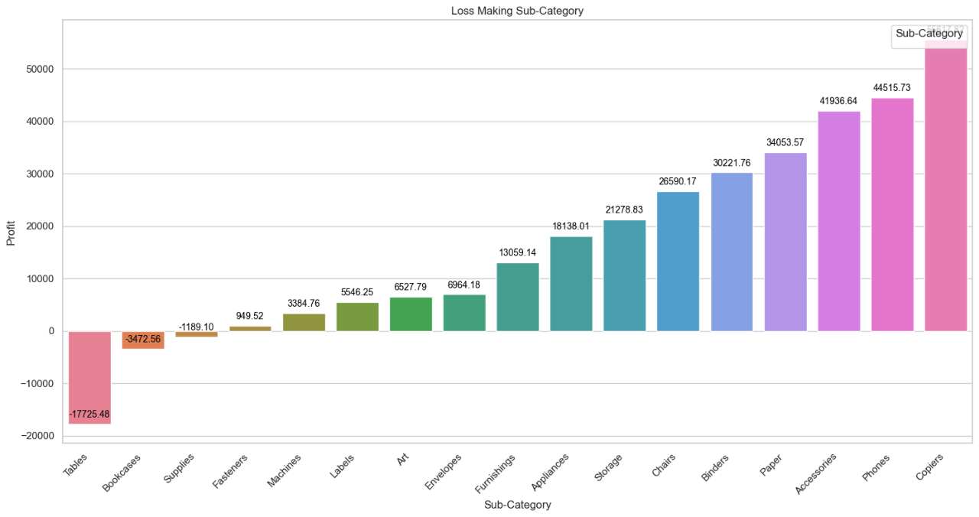

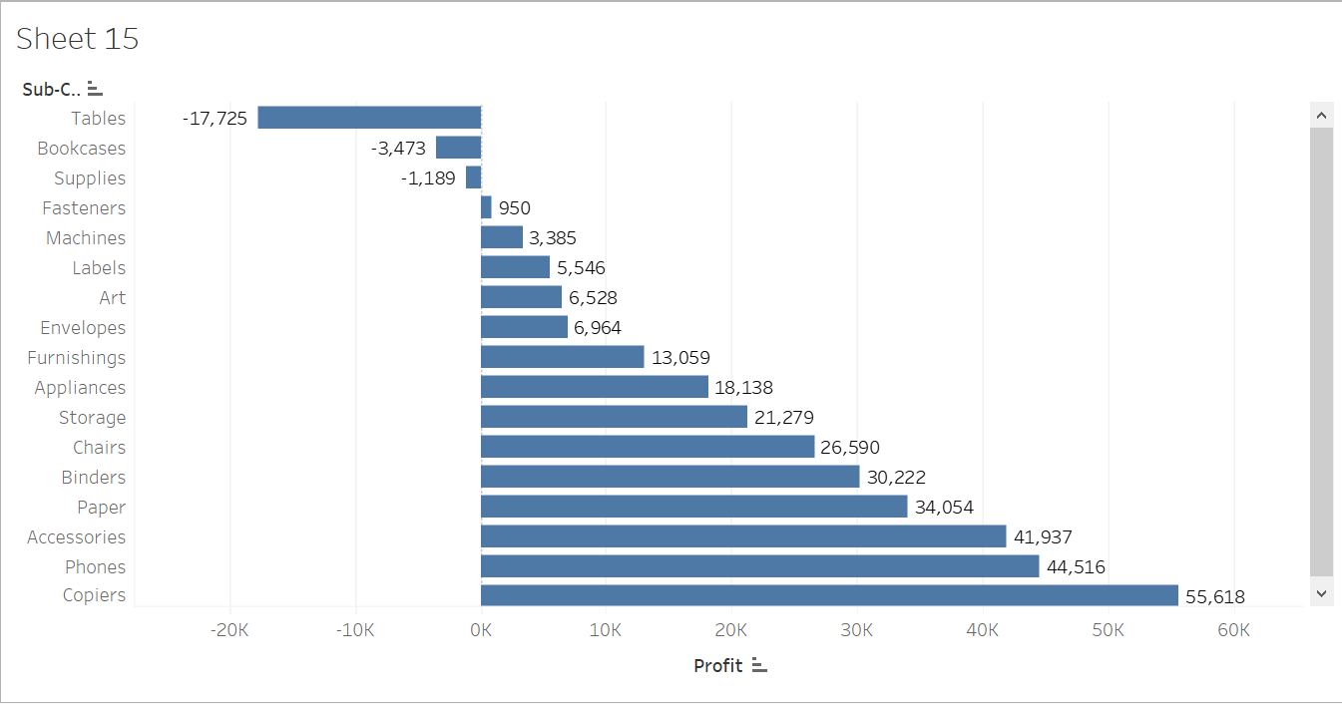**Tableau Workbook :-**

1. **Who are the top 10 customers who order frequently?**

**Code:-**

Top_10_Customers = Dataset['Customer Name'].value_counts()

Top_10_Customers_df = pd.DataFrame({

"Customer Name": Top_10_Customers.index,

"Count": Top_10_Customers.values

})[:10]

plt.figure(figsize=(12, 8))

ax = sns.barplot(

data=Top_10_Customers_df, x="Customer Name", y="Count", hue="Customer Name"

)

for p in ax.patches:

ax.annotate(

format(p.get_height(), ".0f"),

(p.get_x() + p.get_width() / 2.0, p.get_height()),

ha="center",

va="center",

xytext=(0, 10),

textcoords="offset points",

fontsize=10,

color="black",

)

plt.xticks(rotation=45, ha="right")

plt.xlabel("Customer Name")

plt.ylabel("Count")

plt.title("Top 10 Customers")

plt.legend(title="Customer Name", loc="upper right")

plt.tight_layout()

plt.show()

**Output :-**

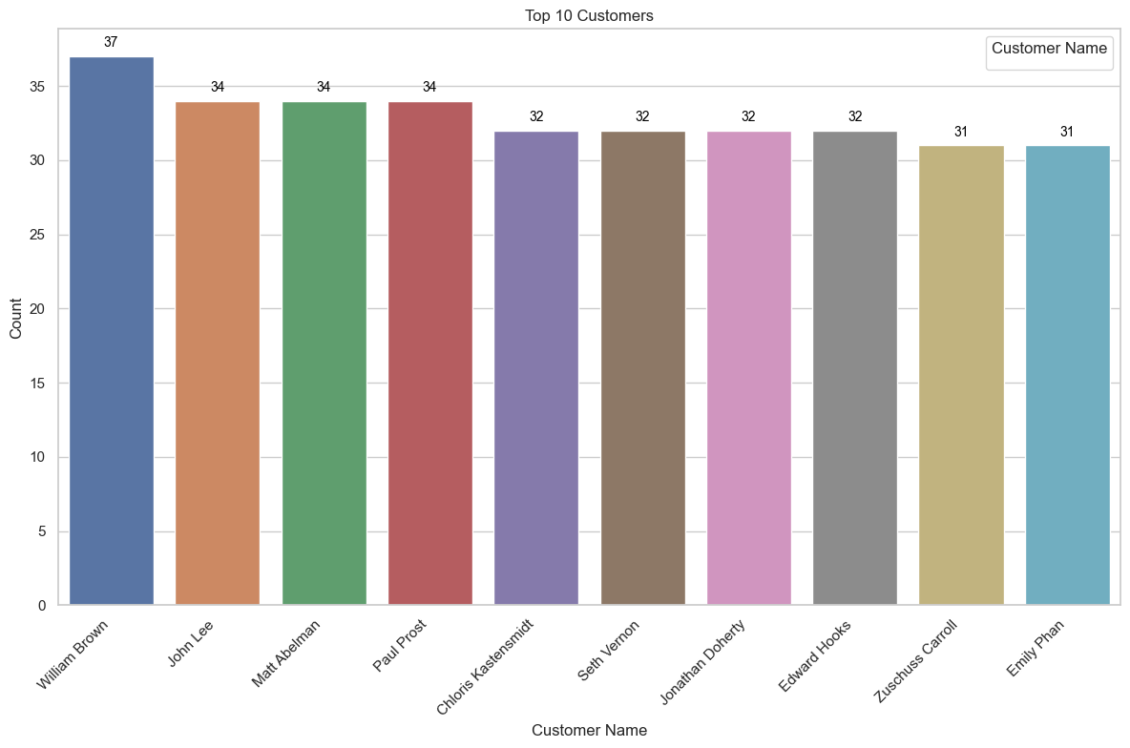

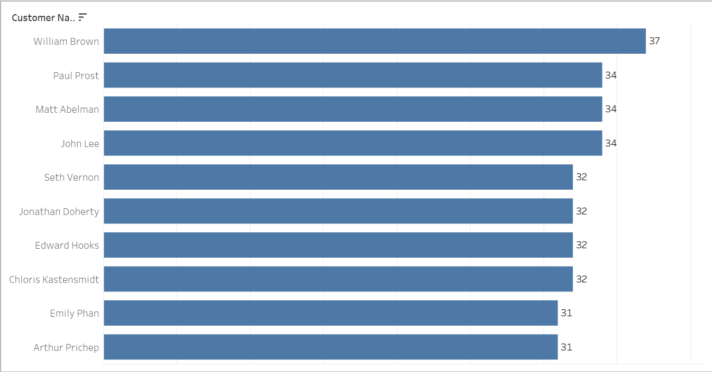**Tableau Workbook :-**

1. **How many unique customers are there in total?**

**Code:-**

unique_customers_count = Dataset["Customer Name"].nunique()

plt.figure(figsize=(8, 6))

bars = plt.bar(["Unique Customers"], [unique_customers_count], color="skyblue")

plt.xlabel("Category")

plt.ylabel("Count")

plt.title("Total Number of Unique Customers")

for bar in bars:

yval = bar.get_height()

plt.text(

bar.get_x() + bar.get_width() / 2,

yval,

round(yval, 2),

va="bottom",

ha="center",

)

plt.xticks(rotation=45, ha="right")

plt.tight_layout()

plt.show()

**Output :-**

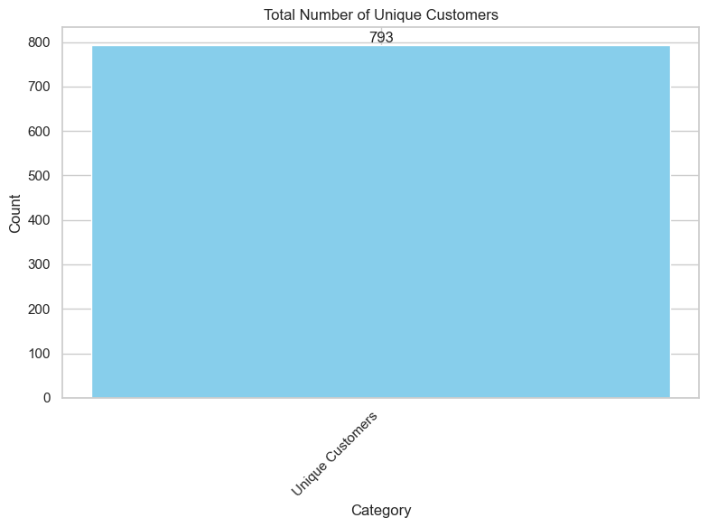

**Tableau Workbook :-**

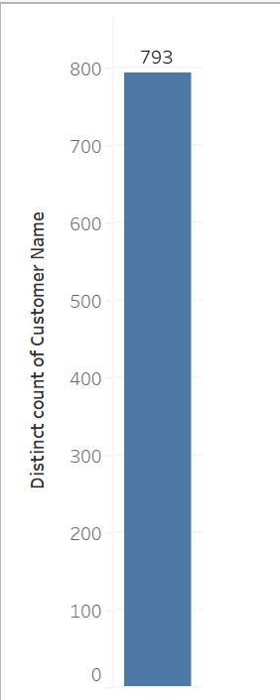

1. **Who are the top 10 profitable customers in New York?**

**Code:-**

New_York_Customers = Dataset[Dataset["State"] == "New York"]

Profitable_Customers = New_York_Customers.groupby("Customer Name")["Profit"].sum()

Top_10_Customers = pd.DataFrame(

{"Customer Name": Profitable_Customers.index, "Profit": Profitable_Customers.values}

).sort_values(by="Profit", ascending=False)[:10]

plt.figure(figsize=(12, 8))

ax = sns.barplot(

data=Top_10_Customers, x="Customer Name", y="Profit", hue="Customer Name"

)

for p in ax.patches:

ax.annotate(

format(p.get_height(), ".0f"),

(p.get_x() + p.get_width() / 2.0, p.get_height()),

ha="center",

va="center",

xytext=(0, 10),

textcoords="offset points",

fontsize=10,

color="black",

)

plt.xticks(rotation=45, ha="right")

plt.xlabel("Customer Name")

plt.ylabel("Count")

plt.title("Top 10 Customers")

plt.legend(title="Customer Name", loc="upper right")

plt.tight_layout()

plt.show()

**Output :-**

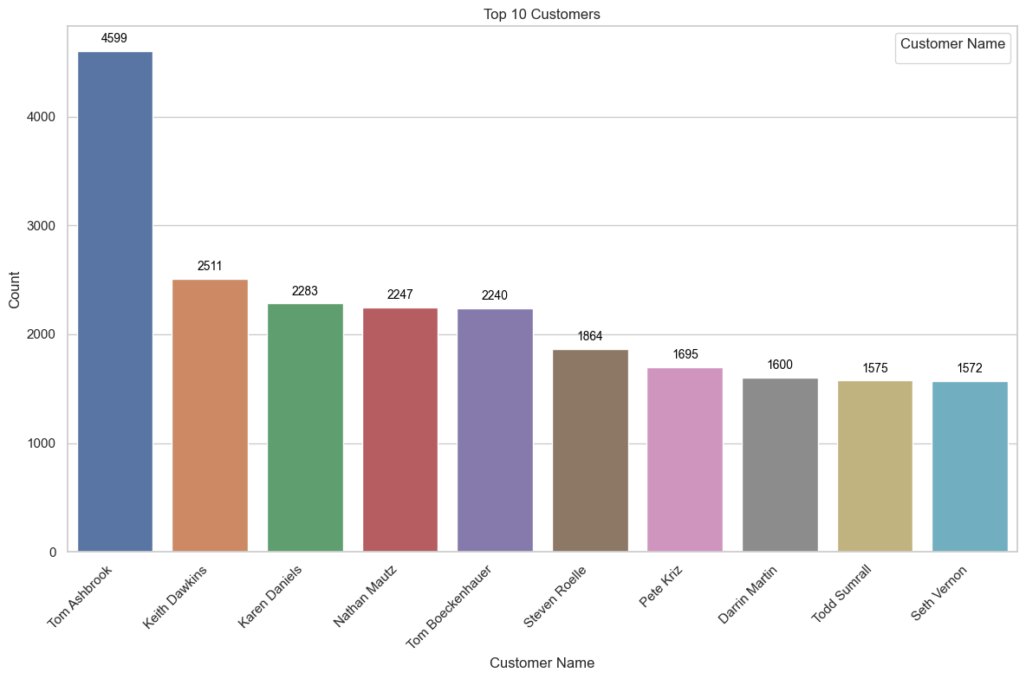

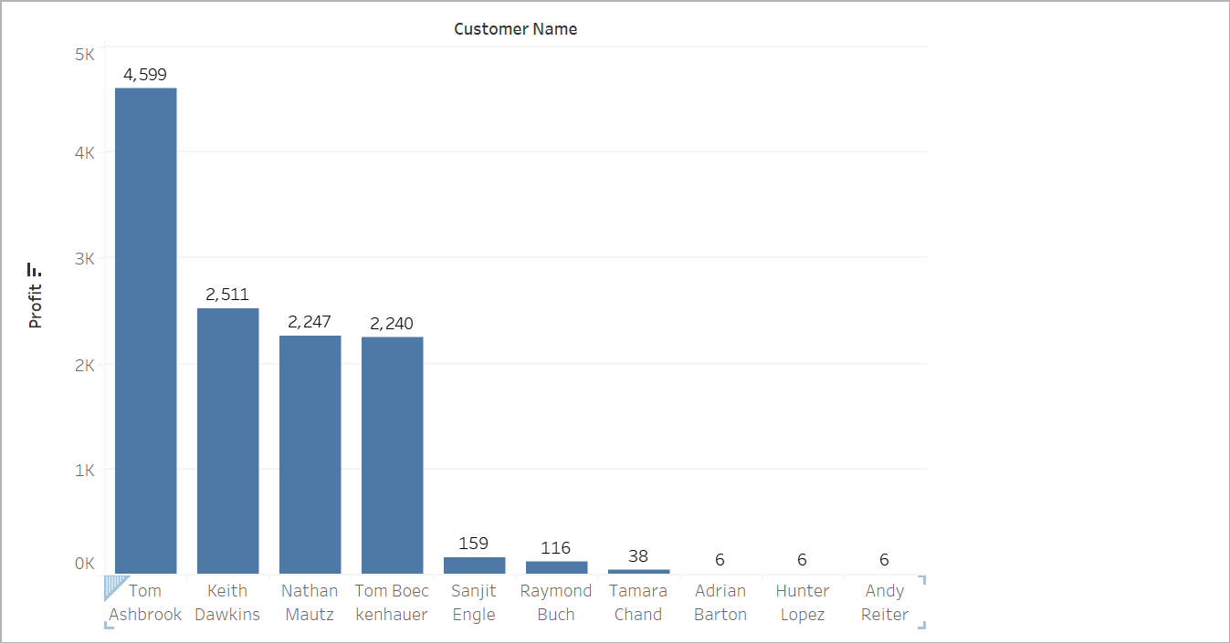**Tableau Workbook :-**

1. **Which product has the maximum time taken to ship?**

**Code:-**

Dataset['Time_to_Ship'] = (Dataset['Ship Date'] - Dataset['Order Date']).dt.days

Product_wies_Ship_Day = Dataset.groupby("Product Name")["Time_to_Ship"].max()

Product_wies_Ship_Day = pd.DataFrame(

{

"Product Name": Product_wies_Ship_Day.index,

"Time to Ship": Product_wies_Ship_Day.values,

}

).sort_values(by="Time to Ship", ascending=False)[:10]

plt.figure(figsize=(12, 8))

ax = sns.barplot(

data=Product_wies_Ship_Day, x="Product Name", y="Time to Ship", hue="Product Name"

)

for p in ax.patches:

ax.annotate(

format(p.get_height(), ".0f"),

(p.get_x() + p.get_width() / 2.0, p.get_height()),

ha="center",

va="center",

xytext=(0, 10),

textcoords="offset points",

fontsize=10,

color="black",

)

plt.xticks(rotation=45, ha="right")

plt.xlabel("Product Name")

plt.ylabel("Time to Ship")

plt.title("Products Having Maximum Shipping Time")

plt.legend(title="Product Name", loc="upper right")

plt.tight_layout()

plt.show()

**Output :-**

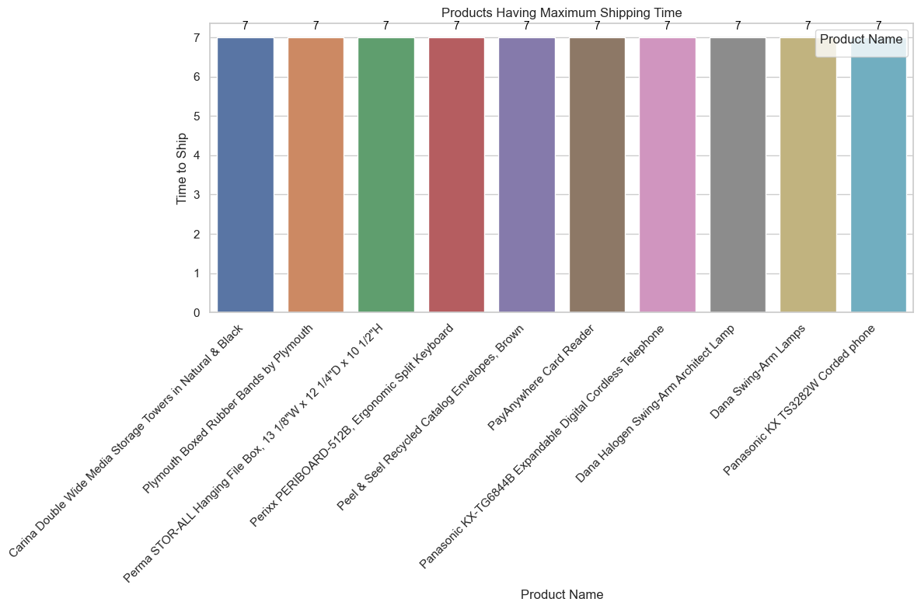

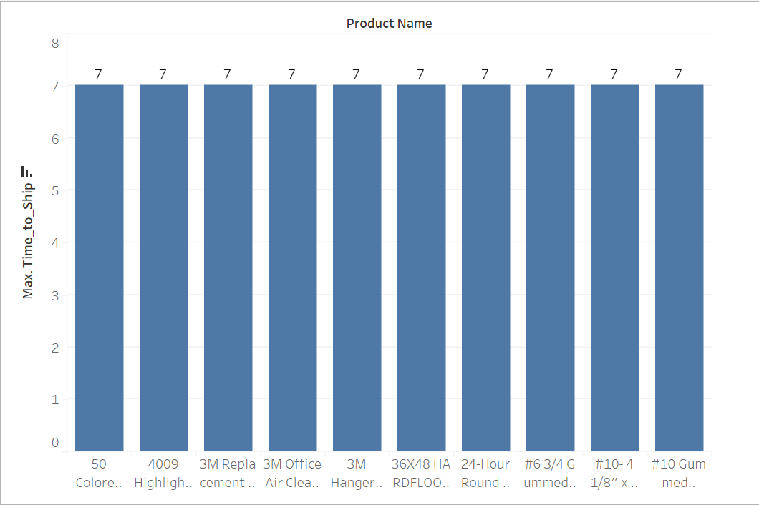**Tableau Workbook :-**

1. **Which category has the maximum time taken to ship?**

**Code:-**

Dataset['Time_to_Ship'] = (Dataset['Ship Date'] - Dataset['Order Date']).dt.days

Category_Ship_Wise_Groupping = Dataset.groupby('Category')['Time_to_Ship'].max()

Category_Ship_Wise_Groupping_df = pd.DataFrame(

{

"Category": Category_Ship_Wise_Groupping.index,

"Time to Ship": Category_Ship_Wise_Groupping.values,

}

).sort_values(by="Time to Ship", ascending=False)[:10]

plt.figure(figsize=(12, 8))

ax = sns.barplot(

data=Category_Ship_Wise_Groupping_df, x="Category", y="Time to Ship", hue="Category"

)

for p in ax.patches:

ax.annotate(

format(p.get_height(), ".0f"),

(p.get_x() + p.get_width() / 2.0, p.get_height()),

ha="center",

va="center",

xytext=(0, 10),

textcoords="offset points",

fontsize=10,

color="black",

)

plt.xticks(rotation=45, ha="right")

plt.xlabel("Category")

plt.ylabel("Time to Ship")

plt.title("Categories Having Maximum Shipping Time")

plt.legend(title="Category", loc="upper right")

plt.tight_layout()

plt.show()

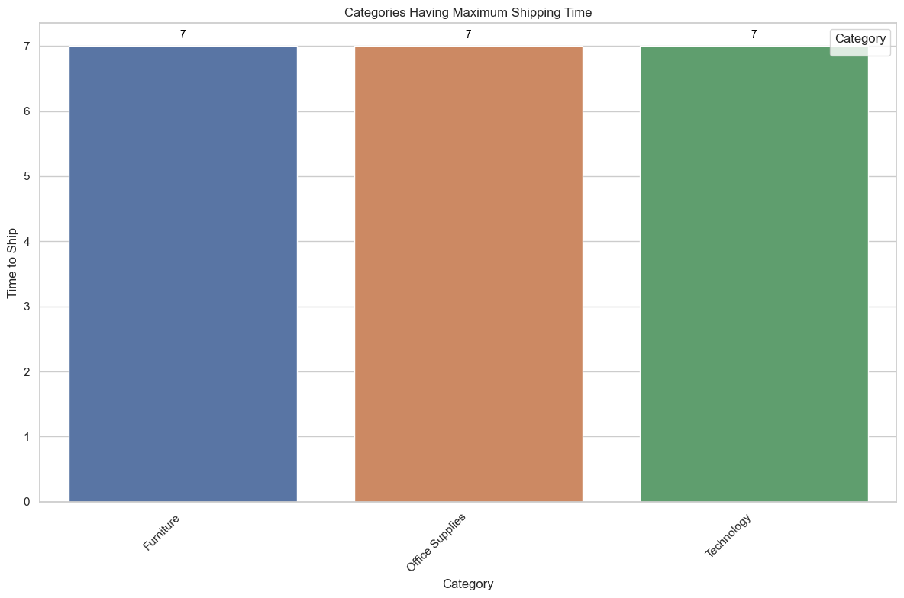**Output :-**

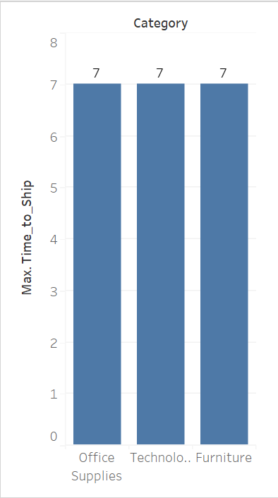**Tableau Workbook:-**

1. **What are the sales and profit figures for each year across all categories?**

**Code:-**

Dataset['Year'] = Dataset['Order Date'].dt.year

Category_Ship_Wise_Groupping = Dataset.groupby('Category')['Time_to_Ship'].max()

Year_wise_profit_and_sales = Dataset.groupby(["Year", 'Category']).agg(

{"Profit": "sum", "Sales": "sum"})

grouped_data = Dataset.groupby(['Year', 'Category'])[['Sales', 'Profit']].sum().reset_index()

pivot_data = grouped_data.pivot_table(index='Year', columns='Category', values=['Sales', 'Profit'])

pivot_data.plot(kind='bar', figsize=(12, 6))

plt.title('Sales and Profit for each year (for all categories)')

plt.xlabel('Year')

plt.ylabel('Amount')

plt.legend(title='Category')

plt.xticks(rotation=45)

plt.show()

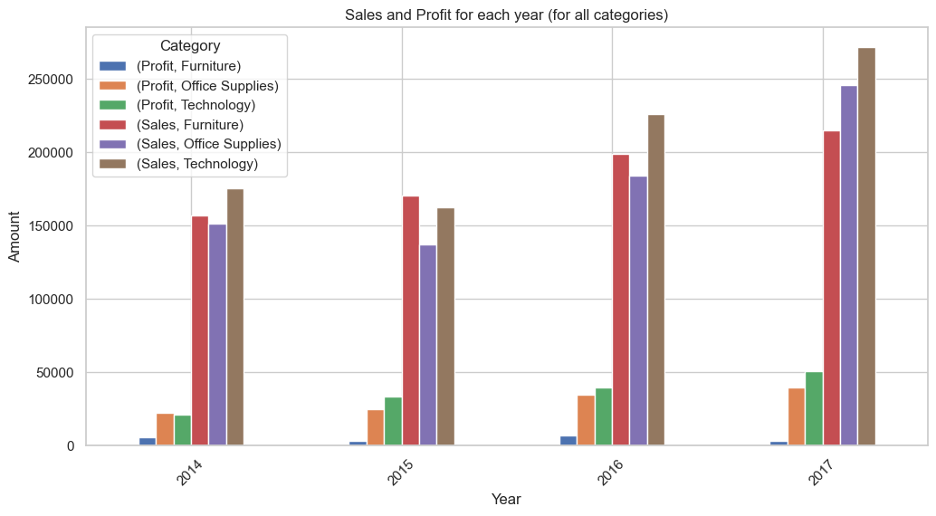**Output :-**

**Tableau Workbook :-**

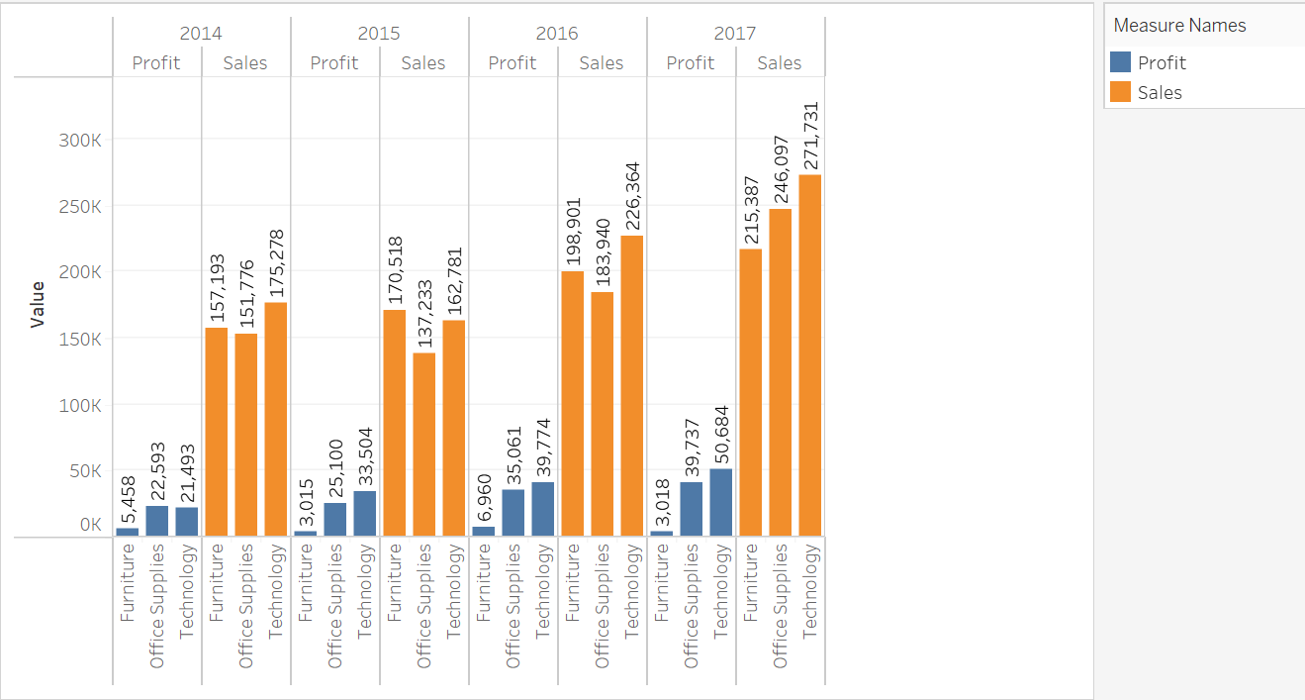

1. **Design the Dashboard of Questions 1, 16, 8, 9, and 21.**

**Code:-**

fig, axs = plt.subplots(3, 2, figsize=(30, 15))

Unique_Categories = list(set(Dataset["Category"]))

axs[0, 0].bar(x=["No Of Unique Categories"], height=[len(Unique_Categories)], width=0.5)

axs[0, 0].set_title("Unique Categories")

Category_wise_Sales_and_profit = Dataset.groupby("Sub-Category")[

["Profit", "Sales"]

].sum()

Category_wise_Sales_and_profit.plot(kind="line", ax=axs[0, 1])

axs[0, 1].set_title("Category-wise Sales and Profit")

axs[0, 1].set_xlabel("Sub-Category")

axs[0, 1].set_ylabel("Amount")

axs[0, 1].grid(True)

axs[0, 1].legend(loc="upper right")

Unique_Products = Dataset["Product Name"].unique()

No_of_Unique_Products = Dataset["Product Name"].nunique()

axs[1, 0].bar(x=["No Of Unique Products"], height=[len(Unique_Products)], width=0.5)

axs[1, 0].set_title("Unique Products")

Top_10_Customers = Dataset["Customer Name"].value_counts()

Top_10_Customers_df = pd.DataFrame(

{"Customer Name": Top_10_Customers.index, "Count": Top_10_Customers.values}

)[:10]

sns.barplot(

data=Top_10_Customers_df,

x="Customer Name",

y="Count",

hue="Customer Name",

ax=axs[1, 1],

)

axs[1, 1].set_title("Top 10 Customers")

axs[1, 1].set_xlabel("Customer Name")

axs[1, 1].set_ylabel("Count")

axs[1, 1].legend(title="Customer Name", loc="upper right")

axs[1, 1].tick_params(axis="x", rotation=45)

pivot_data.plot(kind="bar", ax=axs[2, 0], figsize=(16, 6), legend=True)

axs[2, 0].set_title("Sales and Profit for each year (for all categories)")

axs[2, 0].set_xlabel("Year")

axs[2, 0].set_ylabel("Amount")

axs[2, 0].legend(title="Category")

axs[2, 0].tick_params(axis="x", rotation=45)

plt.show()

**Output :-**

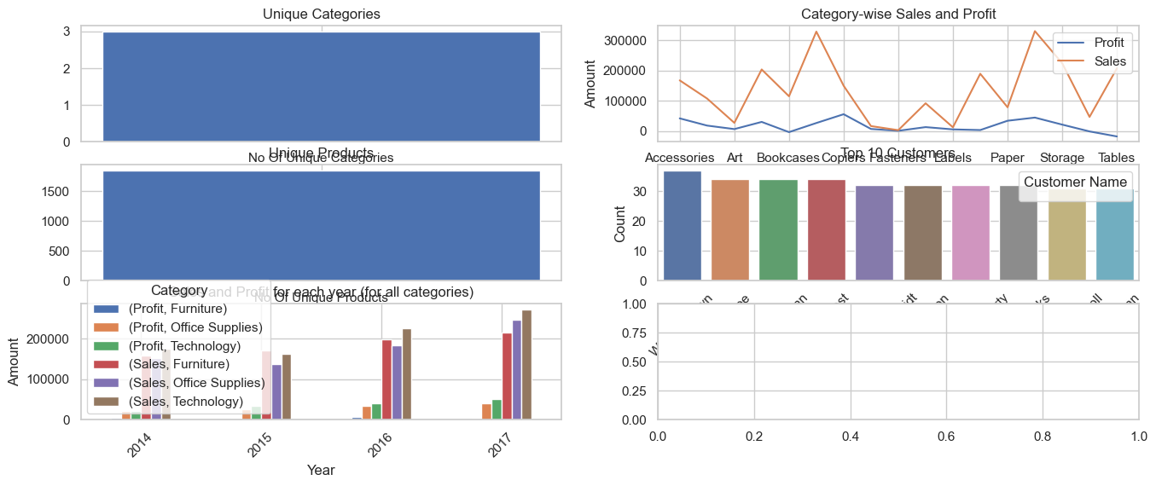

**Tableau Workbook :-**

